**Report**

**about**

**Quad-rotors and payload system dynamics**

By: Ran Dviri, I.D: 040488306, March 2017

Table of Contents

Introduction 2

Numenclature **שגיאה! הסימניה אינה מוגדרת.**

The system model **שגיאה! הסימניה אינה מוגדרת.**

# Introduction

In this paper, I will describe the dynamical system equations of 2 Quad-Rotor (aka quad) units, utilizing a common payload. The equations describe each part with its full 6 Degree-of-Freedom (orientation/attitude and position), and then Implementing some assumptions to constrain the model for 2D plain. The total number of the system’s D.O.F will be described as well.

First I’ll show the dynamics of a single quad. The equations will be derived using the Newton method, and the Lagrangian method. To show correspondence between the two methods.

Then the equations of the entire system will be derived using only Lagrangian method, because it is assumed to be easier in the mathematical sense.

Perhaps some limiting cases will be shown, to verify the model.

The after all purpose is to analyze the system stability according to ‘weakly-nonlinear’ method.

Representative diagram is shown here:

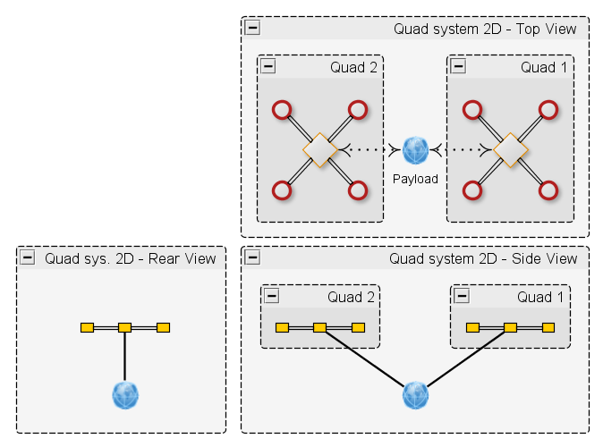

Figure - system views

# Nomenclature

σ : solidity ratio

a : 2D lift coefficient slope

μ : advance ratio

λ : inflow ratio

𝛎 : induced velocity

ρ : air density

$R_{rad}$: rotor radius

$θ_{0}$: pitch of incidence

$θ_{tw}$: twist pitch

$\overline{C_{d}}$: drag coefficient at 70% radial station

l : distance propeller axis to CoG

h : distance propeller plane to CoG

$R_{B}^{I}$: rotation matrix from Body to Inertial coordinate system

$R_{I}^{B}$: rotation matrix from Inertial to Body coordinate system

Acronyms

ESC – [electronic speed control](https://en.wikipedia.org/wiki/Electronic_speed_control)

BEC -  [battery eliminator circuit](https://en.wikipedia.org/wiki/Battery_eliminator_circuit)

PWM – [pulse-width modulation](https://en.wikipedia.org/wiki/Pulse-width_modulation)

FOC - [Field Oriented Control](https://en.wikipedia.org/wiki/Vector_control_(motor)) (related to brushless motors) , [link2](https://www.electrical4u.com/field-oriented-control/)